**Geography 150 Lab: Environmental mapping, landscape evaluation, land use, and site selection**

**Tracy Harvey**

*Introduction*

Preparing an integrated environmental map may require topography, land use, vegetation, soils, water, and geology of an area of interest. Useful information could be provided to city planners and others. Sites for particular types of facilities may be selected or a more regional map may be prepared showing suitability (or vulnerability) of a site for particular land uses.

We will look at an area of your choice (e.g., in western Washington), using the idea of defining environmental resource units (ERUs) on a map.

*Problem*

City planners in your community have asked you to prepare an environmental assessment for land use and suitability for future development, considering geography, geological information, and any other relevant information that we can provide them. Using a terrain map of your region and information on slopes, water, geology, and other information, you are developing a map or maps to assess potential and favorable land use. We are interested in an area of about 25-30 square kilometers or 10-12 square miles.

1. An environmental resource unit (ERU) may be defined using terrain, vegetation, water, and other characteristics. This would be an area of your map with units of your choosing. Examples or samples of ERUs might include:

* River valley and river floodplain

* Flat agricultural land with crops or pasture

* Intermediate hilly terrain with mixed forest and grass

* Mountain forest (forested steeper slopes)

* Wetlands and lakes

* Coastal terraces and tidelands

1. Geological information could added to consider conditions such as:

* Hillslope stability

* susceptibility to high rates of groundwater flow

* Foundation properties or subsidence

*An interactive geological map hosted by the US Geological Survey may be useful to interpret your map area.*

<https://mrdata.usgs.gov/geology/state/map-us.html>

You can zoom in on an area of interest, add or subtract cultural information using the sidebar on the left, and click on a colored area (polygon) to get a geological description of the bedrock of the mapped area. The geological units are described and coded by their age and rock type*. For example, geological units typical of the Puget lowland area immediate surrounding us here in western Washington might include:*

Qal: Quaternary alluvium: river deposits, e.g., sands and silts, dominantly non-glacial

Qog: Quaternary older glacial deposits, e.g., gravels and sands, dominantly glacial drift and associated sediments

LTv: Lower Tertiary volcanic rocks

Quaternary and Tertiary periods refer to the age of the rocks (e.g., the most recent periods in figure below)

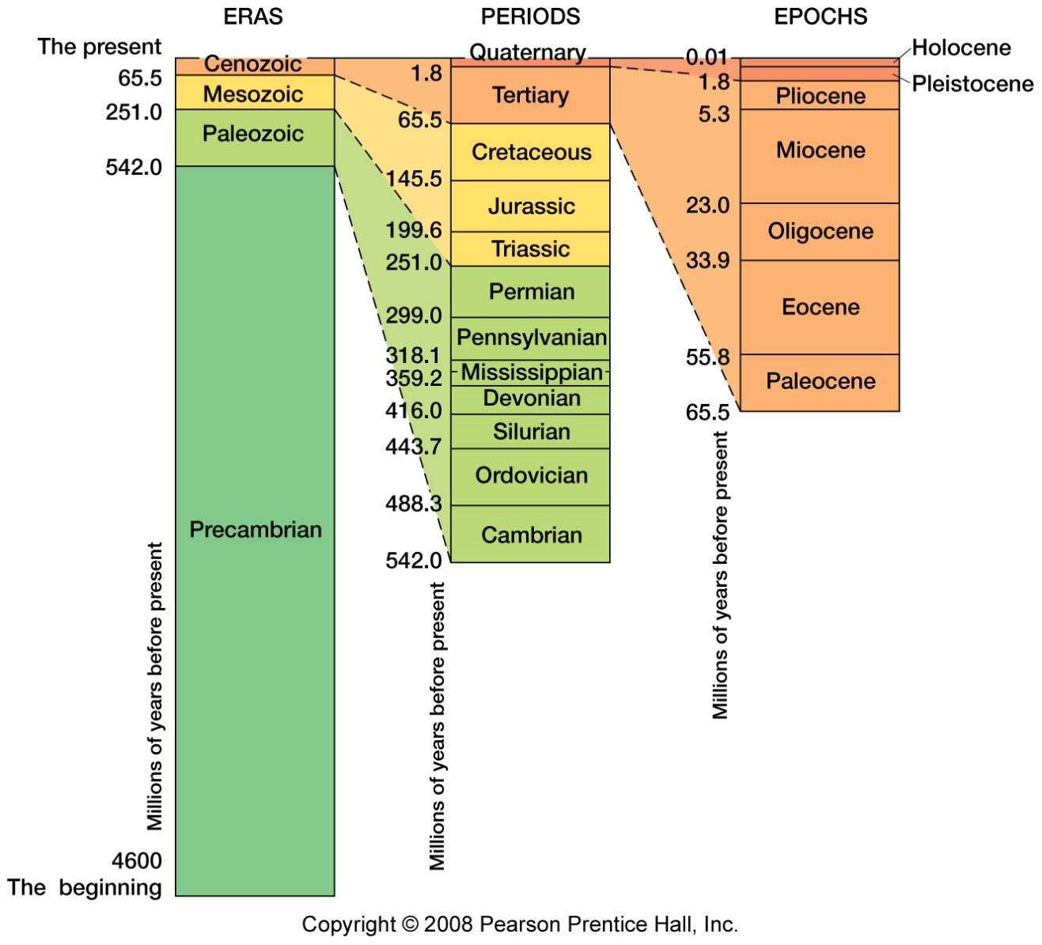

The Lower Tertiary volcanic rocks in our region (LTv) are mostly basalts (e.g., photo below) and tend to be dense and durable rocks that are likely to be more stable on hillslopes.

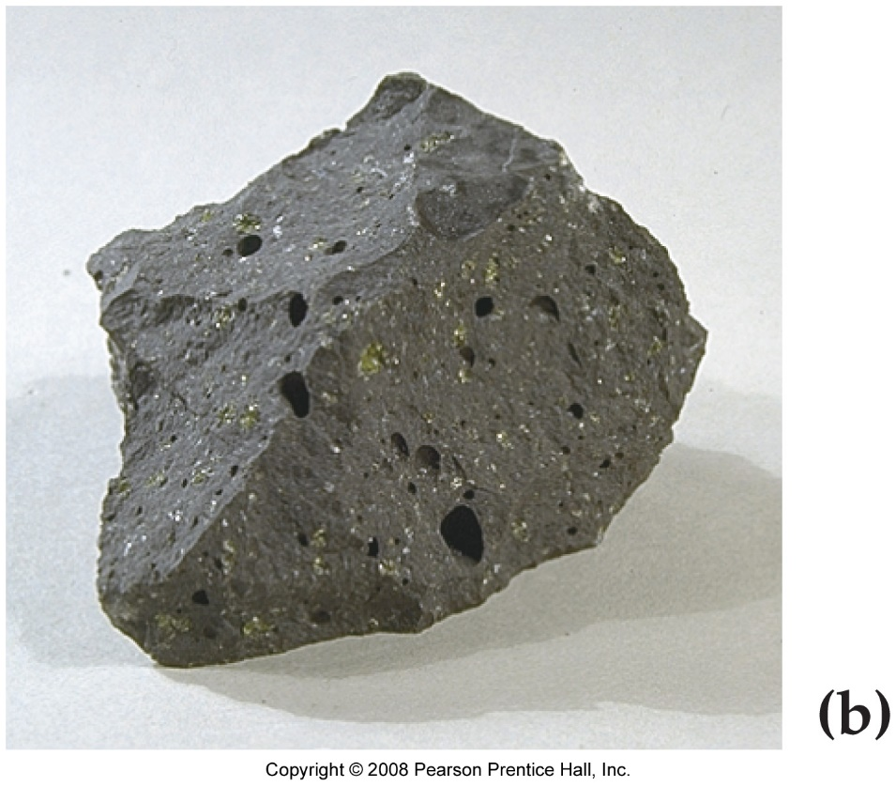

The Quaternary older glacial deposits (Qog) may include rocks like a sand or sandstone (e.g., photo below) and tend to be stable and favorable for drainage, unless in boggy wetland areas.

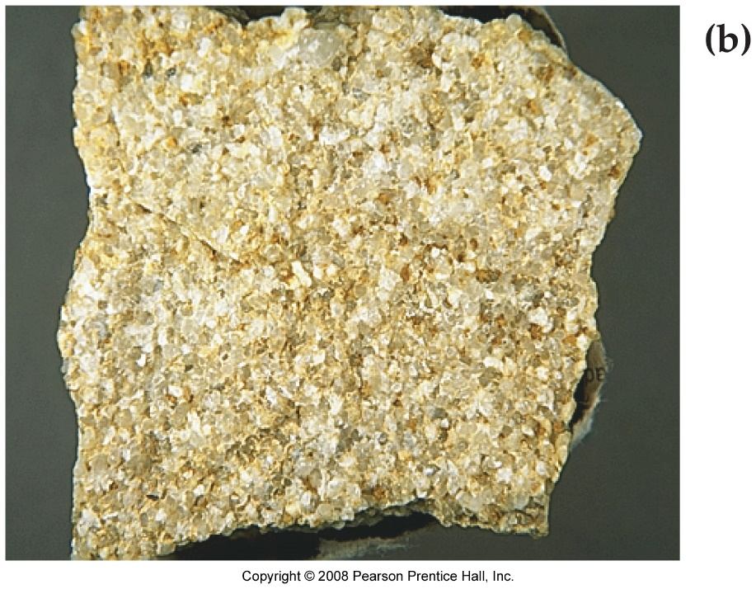

1. Using Google Earth: <https://earth.google.com/web/@48.02102029,-122.80353651,116.06995365a,91770.31697578d,35y,111.93271535h,60.64960129t,0r>, zoom in on an area of about 25-30 sq. km (e.g. 5-6 km on a side) or 10-12 sq. mi. (e.g., 3-4 mi. on a side). These lengths will comprise about 4-5 minutes of a degree. Using map style (left sidebar), click on grid lines (at bottom) and zoom in or out to show your area, listing grid coordinates.

**Grid coordinates:**

**North Boundry: 48.060 N**

**South Boundry: 48.000 N**

**West Boundry: -122.830 W**

**East Boundry: -122.770 W**

Divide your land (or seacoast) area into units of about equal size, say about 2 km on a side. The grid feature will superimpose a uniform grid with smaller boxes as you zoom in. A grid rectangle may be about 500 sq. meters, or 1500 square feet. (Note in GIS parlance, these would be referred to as “polygons” and polygons could also be other geometric shapes.)

We can call the subdivisions of your map “Map units” or Mus.

1. For your map units (MUs), consider ERUs, slope, flood potential, coastal conditions (if applicable), geology, vegetation, aesthetics of undeveloped land, and cultural features (e.g., developed land). Note that you may use the 3-D feature on Google Earth for terrain analysis.

Evaluate the land use capabilities on your map for each subdivision on your map, considering what you can interpret for:

* slope (landslide hazard, slope stability),
* geology (rock type, visible water saturation),
* flood risk (note terrain, dimensions of river valleys if applicable),
* coastal conditions (if applicable)
* cultural features already present, e.g, roads, buildings, transportation networks, other.

Weigh the above factors in importance, e.g, with a numerical (e.g., %) rating or letter/symbol coding system. Note that this system is of your design. Explain how to use your system:

**Scoring System:**

* **Slope Stability (S): A (very stable), B (Stable), C (Moderate), D (Unstable)**
* **Geology (G): (Ideal), B (Good), C (Moderate), D (Poor)**
* **Flood Risk (F): A (Low), B (Moderate), C (High), D (Very High)**
* **Coastal Conditions (C): A: (Ideal), B (Moderate), C (Poor), D (Very Poor)**
* **Cultural features (CF): A (Well-developed), B (Moderately Developed), C (Sparsely Developed), D (Not Developed)**

1. Evaluate your MUs with respect to the following, base on what you can observe on your map:

* Favorable for commercial or industrial uses
* Favorable for residential uses
* Already developed
* Unfavorable for development. Possible recreational uses.

*Note: If we had direct access to a GIS for this term, we could look at polygons of a variety of shapes and sizes. Despite our overview approach, an evaluation like yours earlier in the planning stages of region with a growing population and land use needs could be very important.*

**MU1:**

**Location: Approx. 48.060 N, -122.830 W to 48.040 N, -122.810 W**

**Slope Stability (S): B**

**Geology (G): B**

**Flood Risk (F): A**

**Coastal Conditions (C): B**

**Cultural Features (CF): B**

**Evaluation: Favorable for residential and commercial uses.**

**MU2:**

**Location: Approx. 48.040 N, -122.810 W to 48.020 N, -122.790 W**

**Slope Stability (S): C**

**Geology (G): C**

**Flood Risk (F): B**

**Coastal Conditions (C): C**

**Cultural Features (CF): C**

**Evaluation: Unfavorable for development, potential recreational uses.**

**MU3:**

**Location: Approx. 48.020 N, -122.790 W to 48.000 N, -122.770 W**

**Slope Stability (S): B**

**Geology (G): B**

**Flood Risk (F): B**

**Coastal Conditions (C): B**

**Cultural Features (CF): B**

**Evaluation: Favorable for residential uses.**

**MU4:**

**Location: Approx. 48.000 N, -122.830 W to 48.000 N, -122.810 W**

**Slope Stability (S): D**

**Geology (G): D**

**Flood Risk (F): C**

**Coastal Conditions (C): B**

**Cultural Features (CF): C**

**Evaluation: Unfavorable for development, potential recreational uses.**

1. In conclusion:

* What are the 2-3 best plots or blocks on your map for a residential subdivision? Explain.

**MU1: High slope stability, good geology, low flood risk, and moderate coastal conditions make this unit highly suitable for residential purposes.**

**MU3: Moderate to good in all categories, making it a suitable choice for probable residential development.**

* What are the 2-3 regions on your map that are best left undeveloped? Explain.

**MU2: Poor slope stability, moderate geology, moderate flood risk, and low infrastructure development suggest it should be left undeveloped, possibly used for recreational purposes.**

**MU4: Areas with steep slopes and high landslide risk should be conserved and potentially used for recreation or left as natural spaces.**

* How has the incorporation of terrain, environmental, and perhaps geological factors influenced your recommendations?

**The incorporation of these factors influenced me to use terrain with stable slopes, favorable geology, and low flood risk for development that way the risk to property and lives can minimized and other areas that are considered “high risk” can be used for things like parks or conservation areas.**